How to access exams:
Google “iconnect mwcc”
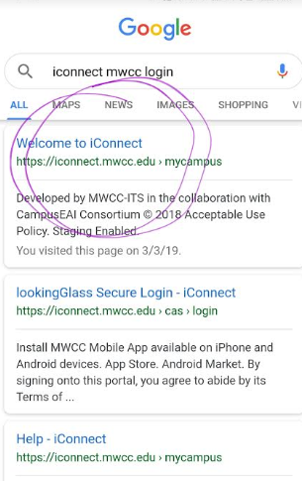
Click circled link.
It will take you to this login screen;
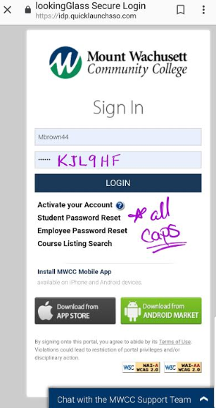
The next page (home page) will look similar to this depending on the device;
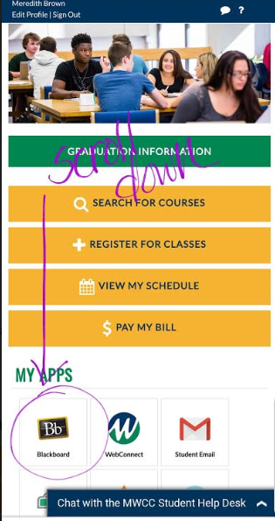
Scroll down to the “MY APPS” section and select the “Blackboard” application. (if by chance it asks you to log in again its still the same log in information as given above)
Once you’re in these are my course listings you’re looking for the one I highlighted in this image. Don’t click on the assignment just click on the course itself in bold for the appropriate link, “201901-ACC226-WEB”.
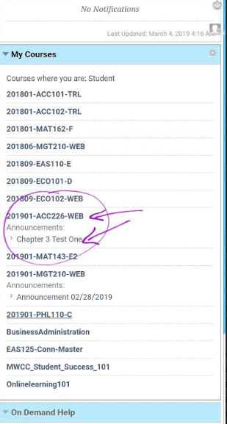
This is what the home page of the course looks like, on the left hand side (there may be a blue tab like thing to click on if the green is not immediately in view) click connect assign;
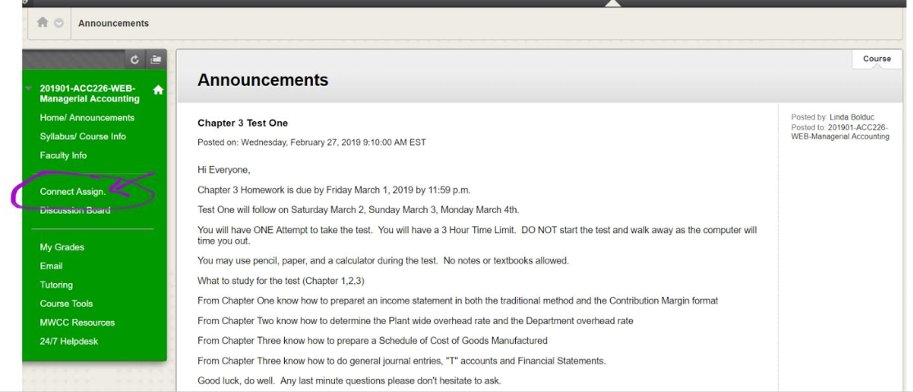
Scroll to the bottom and that is where you will click when you are ready to begin the exam.
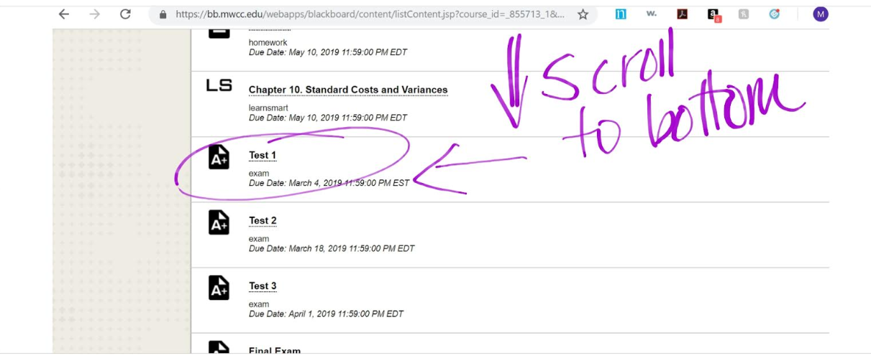

This exam is on chapters 1, 2, & 3. If you scroll back up to the top you will see links to all the assignments for those chapters. You can view each one or “recharge” which lets you redue the assignments without it effecting the grade. Through the “LS” (aka learn smart) assignment links you’ll be able to access the text book.
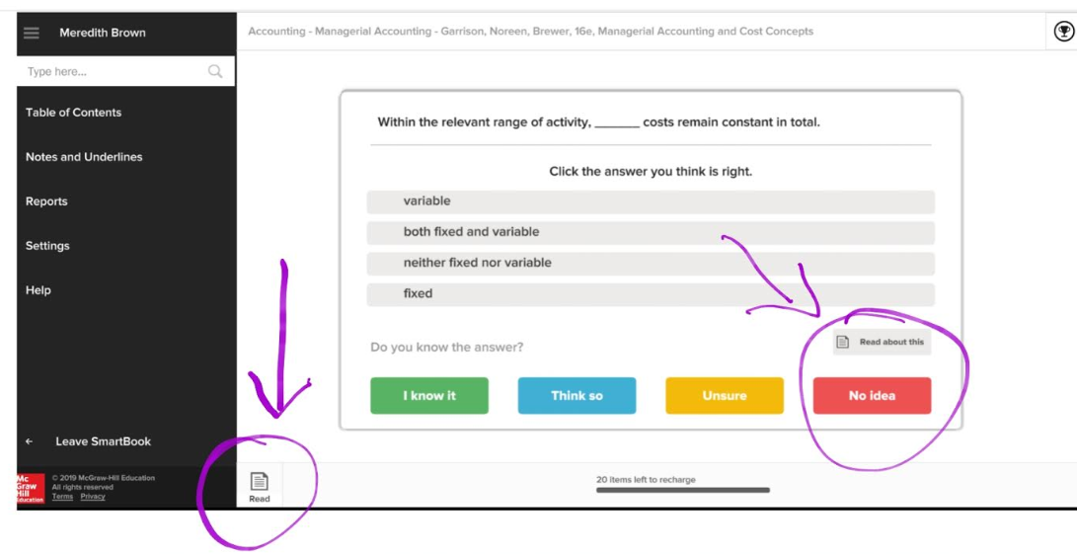
This is what the learn smart pages look like. If you click read in the bottom left it will take you to the section of the text book that will answer that question, however you can flip pages as you please from there. If you would like to just view the answer to the question click “No Idea” and it will give you the answer.

